Install Kubernetes on Cloud

1. Connect to AWS console and navigate to EKS service to create an EKS cluster

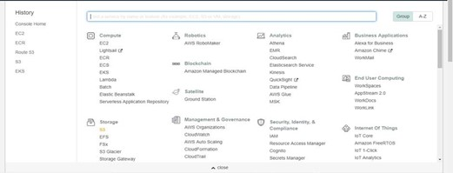

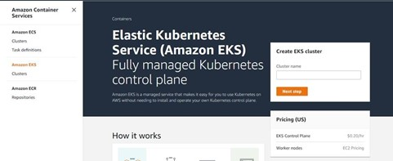

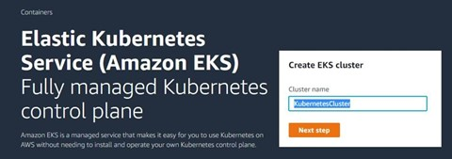

1. Configure **Role name** used by EKS rest.



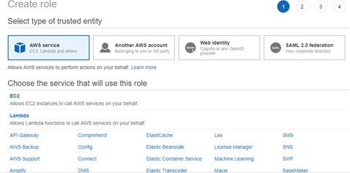

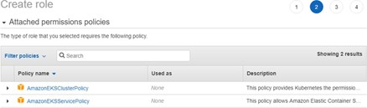

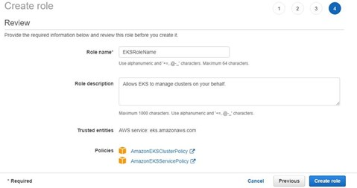

1. Select the newly created role name from the list while creating the EKS cluster

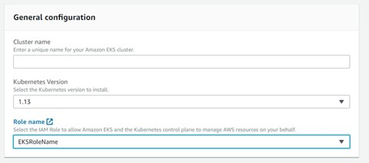

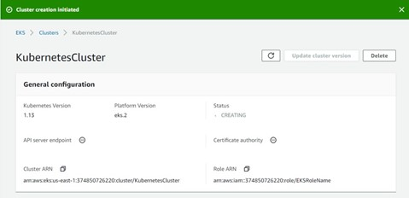

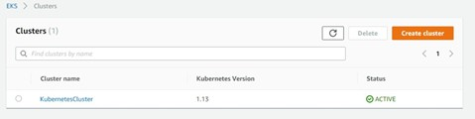

wget [https://amazon-eks.s3-us-west-2.amazonaws.com/1.10.3/2018-07-](https://amazon-eks.s3-us-west-2.amazonaws.com/1.10.3/2018-07-26/bin/linux/amd64/kubectl) [26/bin/linux/amd64/kubectl](https://amazon-eks.s3-us-west-2.amazonaws.com/1.10.3/2018-07-26/bin/linux/amd64/kubectl)

chmod +x kubectl

./kubectl

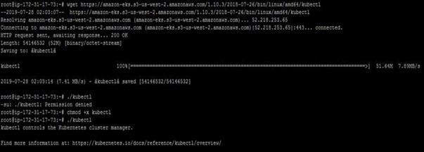

mkdir bin

cp ./kubectl $HOME/bin/kubectl && export PATH=$HOME/bin:$PATH kubectl version

kubectl version --short --client

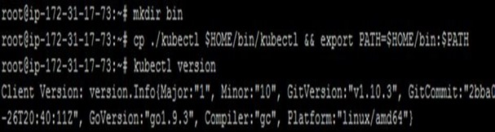

wget [https://amazon-eks.s3-us-west-2.amazonaws.com/1.10.3/2018-07-](https://amazon-eks.s3-us-west-2.amazonaws.com/1.10.3/2018-07-26/bin/linux/amd64/aws-iam-authenticator) [26/bin/linux/amd64/aws-iam-authenticator](https://amazon-eks.s3-us-west-2.amazonaws.com/1.10.3/2018-07-26/bin/linux/amd64/aws-iam-authenticator)

chmod +x ./aws-iam-authenticator

cp ./aws-iam-authenticator $HOME/bin/aws-iam-authenticator && export PATH=$HOME/bin:$PATH

aws-iam-authenticator help

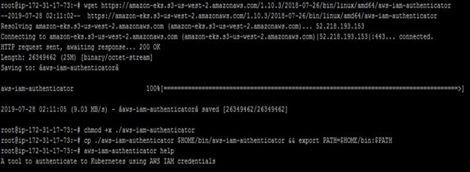

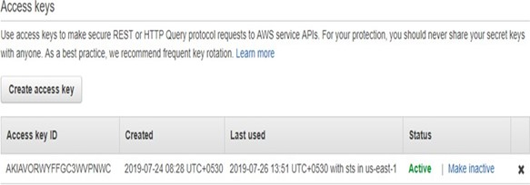

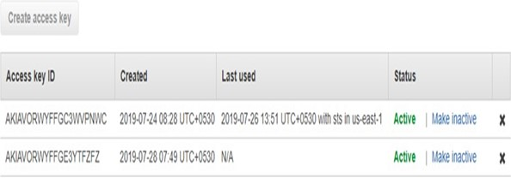

1. Configure AWS CLI and provide **Access Keys** and **Secret Access Keys** while configuring it.

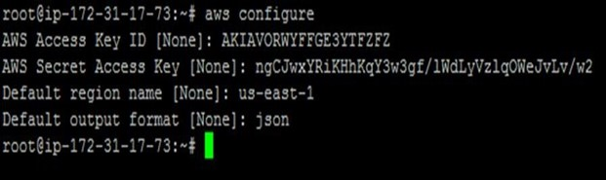

awseks --region us-east-1 update-kubeconfig --name KubernetesCluster kubectl get svc

